**Web services example**

1. Create new Dynamic web project.

File->New->Dynamic web project

Give name of the project and click next.

Again click on next in second screen. In third screen check Generate web.xml check box and click on finish button. Our project is created now.

1. Edit the created web.xml file and add dispatcher servlet to it.

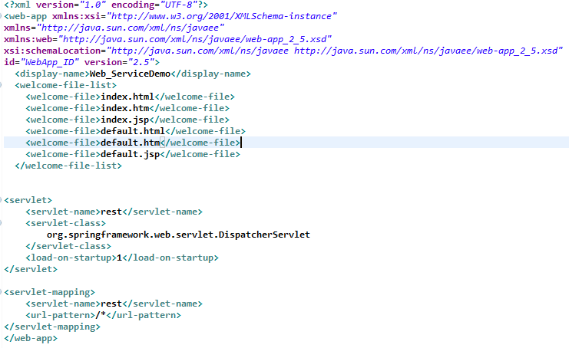

1. Then add rest-servlet.xml file under WEB-INF folder

WebContent->WEB-INF

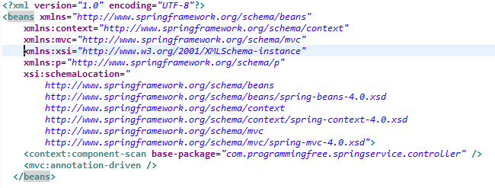

1. Add required jar files to lib folder.

WebContent->WEB-INF->lib

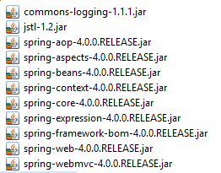

1. Create a package com.springservice.controller in src folder

Then create a controller class in the above created package.

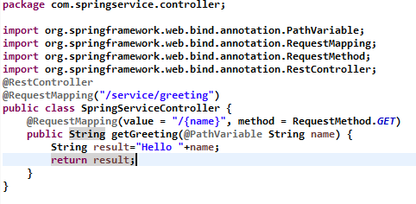

**Final project structure**

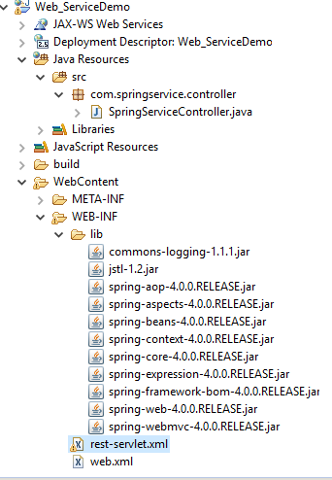

**Output: -**

